**Day – 5 tasks**

1. **Rest api using for, forin ,for of and for each :**

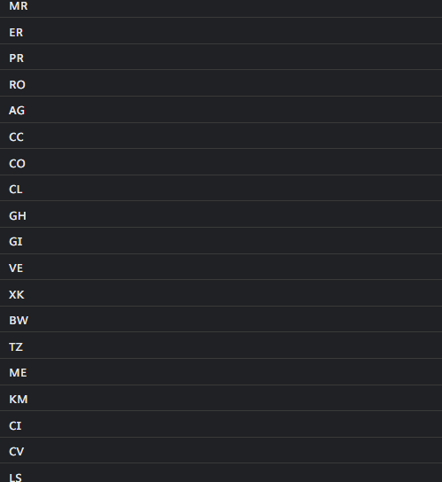

1. **Resume in json format :**

